

INDIA - NAMIBIA CENTER OF EXCELLENCE IN INFORMATION TECHNOLOGY

CERTIFICATE IN BIG DATA TECHNOLOGIES

PROJECT REPORT

TITLE OF THE PROJECT
CLIMATE CHANGE AND ENVIRONMENT DATA
ANALYSIS USING BIG DATA TOOLS

Supervisor
Dr. Arpit Jain

Submitted by
Emily Batubaja Auguste Iitula
(219100462) (225165031)

Kreesan Winkler Karibu Balowa
(225178176) (219125031)

Date of submission:
20/06/2025

DECLARATION
I, Emily Batubaja, Kreesan Winkler, Karibu Balowa & Auguste Iitula hereby declare that the work contained in the proposal for the degree Big Data Technologies project, entitled: “CLIMATE CHANGE AND ENVIRONMENTAL DATA ANALYSIS USING BIG DATA TOOLS’’, is our own original work and that I have not previously in its entirety or in part submitted it at any university or other higher education institution for the award of a degree. I further declare that I will fully acknowledge any sources of information I will use for the project work in accordance with the Institution rules.
Signature: ______________________________
Date: _____________________
SIGNATURE OF THE SUPERVISOR
I, _____________________________, herewith declare that I accept that project is done under my supervision
Signature: _____________________________
Date: _____________________

Table of Contents
DECLARATION _____________________________________________________Page 2
TABLE OF CONTENT ________________________________________________Page 3
LIST OF TABLES ____________________________________________________Page 4
LIST OF FIGURES ___________________________________________________Page 5
ABSTRACT ________________________________________________________Page 7
- INTRODUCTION _______________________________________________Page 8
1.1 Background_______________________________________________ Page 8
1.2 Problem Statement________________________________________ Page 8
1.3 Objectives _______________________________________________ Page 8
- SYSTEM REQUIREMENT ANALYSIS _______________________________ Page 8
2.1 Information Gathering _____________________________________ Page 8
2.2 System Feasibility _________________________________________ Page 8
  - Platform Specification ______________________________________Page 8
    - Hardware Specification _______________________________ Page 8
    - Software Specification _________________________________Page 8
- PROPOSED MODEL / ARCHITECTURE ______________________________Page 9
- METHODOLOGY_______________________________________________ Page 9
  - Procedure and working ________________________________________Page 9
  - Functional Component ________________________________________ Page 9
- DESIGN _________________________________________________________Page 9
5.1 Interface Design ______________________________________________ Page 9
5.2 Database Design ______________________________________________ Page 9
- IMPLEMENTATION AND CODING _________________________________Page 10
- RESULT AND DISCUSSION _________________________________________ Page 11
- LIMITATION _____________________________________________________ Page 11
- CONCLUSION_____________________________________________________ Page 11
- APPENDIX_______________________________________________________Page12-16
REFERENCES ______________________________________________________ Page 12
LIST OF TABLES
Table 1: Hardware Requirements
Table 2: Software Requirements

HARDWARE REQUIREMENT

Hardware Component | Minimum Requirement
Processor (CPU) | Intel Core i5 or higher
RAM (Memory) | 8 GB (recommended for running Cloudera VM smoothly)
Storage | 100 GB HDD or SSD (to accommodate datasets and tools)
Operating System | Windows 10 / Linux (Ubuntu or CentOS for compatibility)
Graphics | Integrated graphics sufficient for Power BI visualizations

SOFTWARE REQUIREMENTS

Software  Components | Purpose
Cloudera Quickstart VM |  | All-in-one Hadoop environment used for HDFS, Hive, and MapReduce operations
Apache Hive |  | Querying and summarizing large datasets using SQL-like syntax
Power BI Desktop |  | Creating visual dashboards, line charts, and forecasting
Microsoft Excel (optional) |  | Data pre-processing or viewing CSV outputs locally
Linux Terminal / Bash |  | Running Hadoop/Hive commands and moving files in Cloudera
Text Editor (e.g., Gedit, VS Code) |  | Writing and editing Hive queries or CSVs if needed
Web Browser |  | Downloading datasets from online sources like NOAA or NASA

LIST OF FIGURES

Power BI Forecast Chart of Temperature Trends

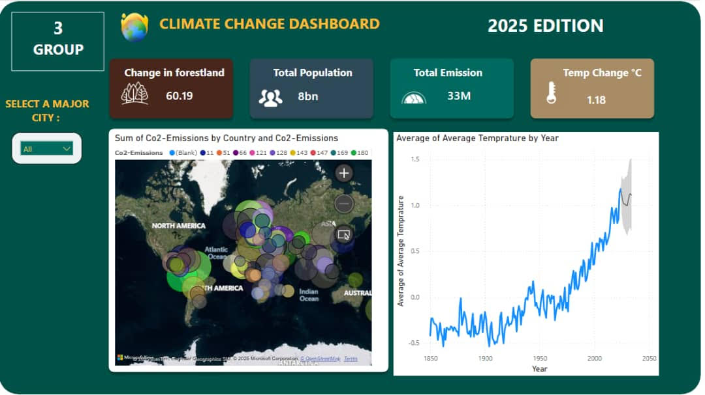
Line Chart

This line chart above, on the right displays the average global temperature anomalies from 1850 to the present. The blue line represents the historical temperature changes, showing a clear upward trend, especially from the mid-20th century onward — a strong indicator of accelerated global warming.”

“The grey line at the end of the chart is a 10-year forecast, automatically generated by Power BI using the historical data trend. It projects temperatures from 2024 to 2033, and as we can see, the upward trend is expected to continue or even steepen.”

“The shaded grey area around the forecast line is called the confidence interval — it shows the range within which the future values are likely to fall, based on historical patterns. This helps us understand not just the trend, but also the possible uncertainty in prediction.”

“The key takeaway is that if no major interventions occur, the Earth's average temperature will likely keep rising, reinforcing the urgent need for climate action.”

Co2 Heat Map

The Co2 heat map displays the amount of Co2 gas produced within each and every country within the globe. The countries are listed in with in the map and the different colors represent the co2 levels produced by each country, the bigger the circle the higher the levels.

The significance of this is that Co2 levels are directly linked to the rise in temperature as Co2 is a greenhouse gas which initially isn’t a problem in its self but the issue occurs when massive number of trees are cut down by companies that do not consider that plant life directly counters the greenhouse effect.

Considering that Greenhouse effect is long lasting and can linger for generations, should alert the individuals of today to bring about awareness and act against this phenomenon so that the future population has an easier time to deal with this issue.

Change in forestry

As Trees are a necessary component in curbing the Co2 Gas the monitoring and tracking the rate at which they are being brought down, which is explained within the Co2 Heat Map paragraph. This will hopefully raise concerns for activists and individuals alike to take action against this ongoing issue.

The Population and Total Emissions

These indicators display the global Population and the global Emissions that are released by these populations which is measured in parts per million.

ABSTRACT

Climate change is one of the most pressing global challenges. Understanding, monitoring, and predicting climate trends require the ability to process large datasets effectively. This project applies Big Data technologies to environmental data to analyze historical temperature trends and forecast future climate anomalies. Using Hadoop for distributed data storage, Hive for data querying, and Power BI for interactive visualizations, the study demonstrates how data-driven tools can provide crucial climate insights. The dataset used includes average temperature anomalies per year from NASA and NOAA sources. The output includes a forecast showing a probable continued rise in global temperature anomalies over the next decade. The study emphasizes the importance of data analytics in supporting climate awareness and policy-making and proposes future enhancements such as real-time data streaming and machine learning-based forecasting.

INTRODUCTION

1.1 Background
Climate change has accelerated significantly due to human activities such as deforestation, fossil fuel use, and industrialization. Environmental monitoring systems must now handle vast volumes of data generated from satellites, sensors, and global research networks. Traditional systems are inadequate for this scale, hence the need for Big Data solutions.

1.2 Problem Statement
Many regions lack the tools to process and visualize large-scale environmental datasets. Without real-time monitoring and trend analysis, policymakers and environmental researchers cannot act swiftly or accurately. Traditional data systems fail in terms of scalability, performance, and interactivity.

1.3 Objectives
To apply Big Data tools (Hadoop, Hive) to climate datasets, to visualize temperature anomaly trends from 1850 to present, to forecast future climate changes using predictive analytics in Power BI, to propose a scalable system for future environmental analytics.

2. SYSTEM REQUIREMENT ANALYSIS

2.1 Information Gathering

Data was gathered from NASA Earth Data, NOAA Climate Data, and the World Bank API, focusing on average global temperature anomalies from 1850 to recent years.

2.2 System Feasibility
The system is technically feasible using Cloudera's Hadoop environment, with minimal hardware requirements. The tools used are open-source or freely available for academic purposes.

2.3 Platform Specification

2.3.1 Hardware Specification
Intel Core i5 processor or above 8 GB RAM minimum 100 GB storage (HDD or SSD)
2.3.2 Software Specification
Cloudera QuickStart VM (Hadoop, Hive) Microsoft Power BI Microsoft Excel (optional preprocessing).

3. PROPOSED MODEL / ARCHITECTURE
The project follows a modular architecture:
1. Data Collection from reliable online sources
2. Storage into Hadoop Distributed File System (HDFS)
3. Data Querying and Transformation using Apache Hive
4. Export of summarized data to CSV
5. Visualization using Power BI This architecture ensures scalability, fault-tolerance, and real-time extension in future upgrades.

4. METHODOLOGY

4.1 Procedure and Working
• Download dataset from NOAA (CSV format)
• Upload dataset into HDFS using Cloudera VM
• Create external Hive table and load data
• Query data to find yearly average anomalies
• Export results as CSV
• Load CSV into Power BI and create line chart with 10-year forecast.

4.2 Functional Components
• Data ingestion: HDFS and Hive
• Processing: Hive SQL queries
• Export: Hive `INSERT OVERWRITE LOCAL DIRECTORY`
• Visualization: Power BI forecasting model

5. DESIGN

5.1 Interface Design
• Hive command-line interface (CLI) for queries
• Power BI interface for visual exploration and forecasting

5.2 Database Design

The Hive table contains:
• source (string)
• year (int)
• temp\_anomaly (float)

6. IMPLEMENTATION AND CODING

Key Hive commands used for Line graph Table:
HQL

CREATE EXTERNAL TABLE
climate_data (
source STRING,
year INT,
temp_anomaly FLOAT
)
ROW FORMAT DELIMITED FIELDS TERMINATED BY ',' STORED AS TEXTFILE LOCATION '/user/cloudera/climate';

INSERT OVERWRITE LOCAL DIRECTORY '/home/cloudera/climate_output' ROW FORMAT DELIMITED FIELDS TERMINATED BY ',';
SELECT year,
AVG(temp_anomaly)
FROM climate_data
WHERE year IS NOT NULL
GROUP BY year
ORDER BY year;

Hive key command used for heat map Table:
HQL

-- Create your Table & place it within Cloudera

CREATE EXTERNAL TABLE world_data_2024(
Country STRING,
Abbreviation STRING,
Capital/Major City STRING,
Co2-Emissions BIGINT,
Forested area(%) DOUBLE,
Largest city STRING,
Population BIGINT,
Urban_Population BIGINT,
Latitude DOUBLE,
Longitude DOUBLE,
)
ROW FORMAT DELIMITED FIELDS TERMINATED BY ',' STORED AS TEXTFILE LOCATION '/user/cloudera/';

-- Insert data from the original CSV file to the the table you have created:

INSERT INTO TABLE map
SELECT * FROM world_data_2024;

-- Clean up:

Drop Table world_data_2024;

-- After the file is stored within cloudera it is then imported as a csv file into power bi and when viewed as a table, this is what is displayed.

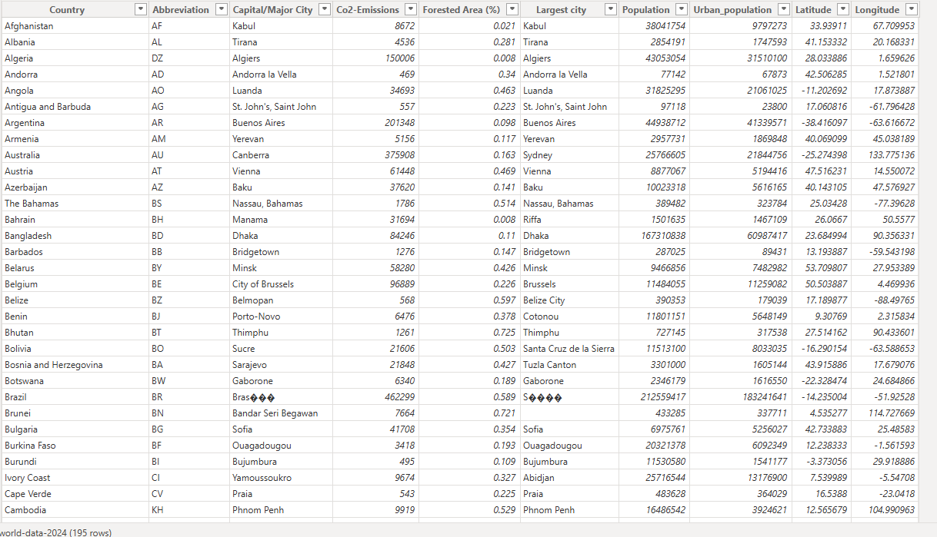

7. RESULT AND DISCUSSION
The Power BI dashboard shows a clear upward trend in average global temperature anomalies from 1850 to 2023. The 10-year forecast projects a continued increase in temperature anomalies, signaling worsening global warming. These insights can help raise awareness and drive sustainable climate action.

8. LIMITATION
• Data only includes one indicator (temperature anomaly)
• Does not use real-time data ingestion (e.g., streaming)
• Forecast model is based on historical trend only (no ML integration)

9. CONCLUSION
The project successfully demonstrates how Big Data tools can process large-scale climate datasets and visualize trends. Forecasting with Power BI provides accessible insights for non-technical stakeholders. Future improvements can include streaming data, multiple indicators, and integration with machine learning models for smarter predictions.

Appendix: Step-by-Step Implementation
Step 1: Dataset Download and Preparation
- The CSV dataset was downloaded from NOAA’s open data portal.
- It contained global temperature anomalies from 1850 to 2023.
- We uploaded the data to Hadoop using WinSCP to Home cloudera.
Step 2: Uploading the Dataset to HDFS
- Using the Cloudera terminal, I created a directory in HDFS:
hdfs dfs -mkdir /user/cloudera/climate
hdfs dfs -put climate_data.csv /user/cloudera/climate/
This made the file accessible across the Hadoop ecosystem.
Step 3: Creating an External Table in Hive
- A Hive table was created to read the CSV data directly from HDFS:
CREATE EXTERNAL TABLE climate_data (
source STRING,
year INT,
temp_anomaly FLOAT
)
ROW FORMAT DELIMITED
FIELDS TERMINATED BY ','
STORED AS TEXTFILE
LOCATION '/user/cloudera/climate';
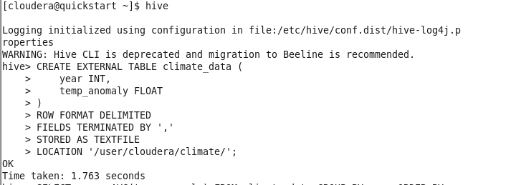
This allowed SQL-like querying of the dataset using Hive.
Step 4: Querying the Data with Hive
- To analyze the average temperature anomaly per year, I used:
SELECT year, AVG(temp_anomaly)
FROM climate_data
WHERE year IS NOT NULL
GROUP BY year
ORDER BY year;
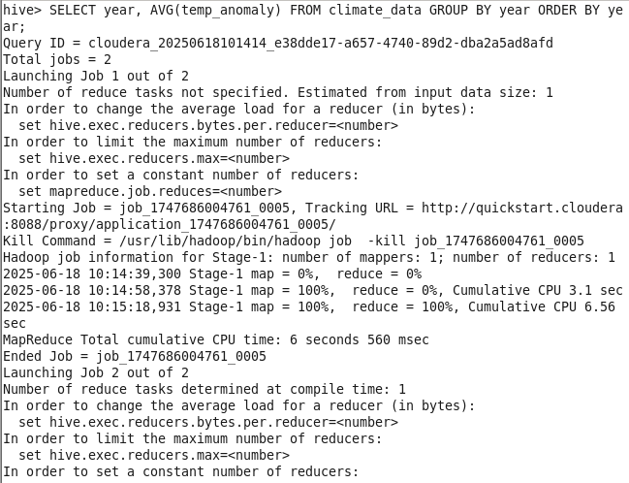
Step 5: Exporting Results for Power BI
- The output of the Hive query was exported to the local file system:
INSERT OVERWRITE LOCAL DIRECTORY '/home/cloudera/climate_output'
ROW FORMAT DELIMITED
FIELDS TERMINATED BY ','
SELECT year, AVG(temp_anomaly)
FROM climate_data
WHERE year IS NOT NULL
GROUP BY year
ORDER BY year;

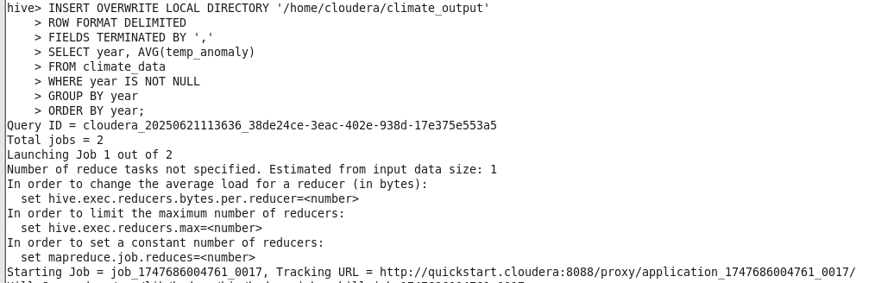
Then it was converted to a CSV:
- cat 000000_0 > climate_trends.csv
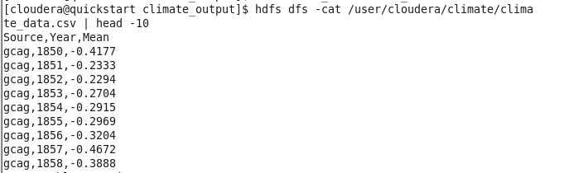

Step 6: Loading Data into Power BI
- The climate_trends.csv file was imported into Power BI.
- A line chart was created using Year (X-axis) and Avg Temp Anomaly (Y-axis).
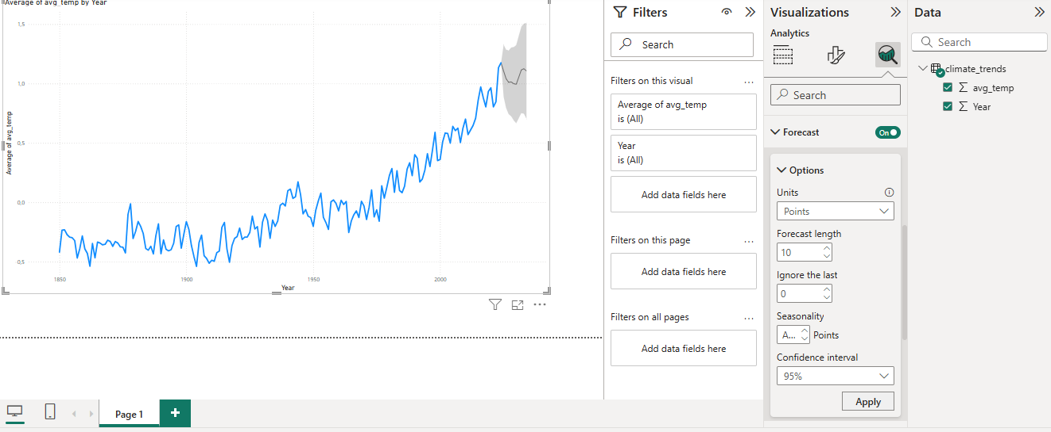
Step 7: Applying a Forecast in Power BI
- A 10-year forecast was added using Power BI’s analytics pane:
  - Forecast Length: 10 Years
  - Confidence Interval: 95%
- The grey dotted line represents the projected anomalies for 2024–2033.

Step 8: Visualization and Analysis
- The final Power BI chart clearly shows the historical trend and forecast.
- The graph supports the conclusion that global warming is continuing.

REFERENCES

• NASA Earth Data. (2023). [https://earthdata.nasa.gov/](https://earthdata.nasa.gov/)

• NOAA Climate Data Online. (2023). [https://www.ncei.noaa.gov/cdo-web/](https://www.ncei.noaa.gov/cdo-web/)

• World Bank Climate Data API. (2023). [https://datahelpdesk.worldbank.org/knowledgebase/articles/889392](https://datahelpdesk.worldbank.org/knowledgebase/articles/889392)

• Apache Hive Documentation. (2023). [https://hive.apache.org/](https://hive.apache.org/)

• Microsoft Power BI Documentation. (2023). [https://learn.microsoft.com/en-us/power-bi/](https://learn.microsoft.com/en-us/power-bi/)

• Dean, J., & Ghemawat, S. (2008). MapReduce: Simplified Data Processing on Large Clusters. Communications of the ACM, 51(1), 107-113.

- Shreya sur (2025) Atmospheric CO2 concentration data from 2015 to 2025, showing trends and cycles
CO2 Levels (2015-2025): Trends & Cycles | www.kaggel.com

<END>

